MONTREAL PROTOCOL
ON SUBSTANCES THAT DEPLETE
THE OZONE LAYER

UNEP

2014 REPORT OF THE
RIGID AND FLEXIBLE FOAMS TECHNICAL OPTIONS COMMITTEE

2014 ASSESSMENT REPORT

UNEP
Report of the
Rigid and Flexible Foams Technical Options Committee
2014 Assessment Report

Published March 2015
ISBN: 978-9966-076-10-6
Contents
1. Key Messages 5
2. Executive Summary 6
Trends in Global Foam Use and Impacts on Blowing Agent Consumption 6
Overview of Progress and Challenges related to Blowing Agent Transitions 7
Update on Bank Estimates and Emerging Management Strategies 8
3. Trends in Global Foam Use and impacts on Blowing Agent Consumption 10
Growth in Global Foam Use 10
Impact on Blowing Agent Consumption 11
Projection of Business-as-Usual Trends to 2020 11
4. Overview of Progress and Challenges Related to Blowing Agent Transitions 12
Progress with HCFC Phase-out Management Plans (HPMPs) in the Foam Sector 12
Particular Challenges with PU Spray Foams and Extruded Polystyrene 12
Enterprise Size and Economies of Scale 14
Drivers for reducing Saturated HFC use in Non-Article 5 Parties 14
Summary 14
5. Low-GWP Alternatives by type and their significance in the Foam Sector 15
Broadening acceptance of Hydrocarbons 15
Carbon Dioxide as a blowing agent 16
Latest Status of Unsaturated HFC/HCFC Developments 16
Progress with other Low GWP Alternative Blowing Agents 17
6. Review of blowing agent selection by foam sub-sector and region 18
Polyurethane Foams in the Refrigeration Sector 18
Polyurethane Boardstock 21
Polyurethane Panels 24
Polyurethane Spray 26
Polyurethane In-situ/Block 29
Polyurethane Integral Skin 31
Extruded Polystyrene Foam 34
Phenolic Foam 36
7. Update on Bank Estimates and Emerging Management Strategies 39
Estimated size of current Blowing Agent Banks and predicted growth to 2020 39
Identifying Blowing Agents in the Waste Stream and other Waste Management challenges 39
Assigning value to Blowing Agent recovery and likely impact on trends going forward 39
Best Practice in the management of Insulation Foams and the importance of Segregation 40
8. Membership of the Foams Technical Options Committee 42

Key Messages

- Growth in the construction sector in Article 5 parties, coupled with the adoption of enhanced energy efficiency criteria for buildings has led to a growth in demand for thermal insulation materials in these regions

- Insulation foams have been the material of choice, although concerns over flammability have hindered adoption in some key markets, particularly where construction methods expose hazards. Differentiation between product types is increasingly occurring

- In non-Article 5 parties, an increasing focus for insulation use has been in existing buildings, where solutions are required to be both efficient and cost-effective. PU Spray foam has made considerable inroads as a result.

- Global blowing agent consumption is estimated to have reached approximately 390,000 tonnes annually in 2014 and is expected to continue to grow at around 4.8% per year through to 2020, leading to an overall consumption in excess of 520,000 tonnes with hydrocarbons representing over 50% of the total.

- The enactment of Decision XIX/6 has been the major driver for blowing agent transitions since 2010, although the implementation of Stage 1 of HCFC Phase-out Management Plans (HPMPs) has been hampered in some regions by administrative procedures.

- The focus of HCFC phase-out in the foam sector to date has been HCFC-141b based on the “worst-first” principle. However, this has led to a significant tail of HCFC-142b/22 use in the XPS sector which has continued to grow rapidly since 2010, particularly in Asia.

- There is some evidence to suggest that the XPS growth may have caused a nominal ‘breach’ in the 2013 freeze for Article 5 parties when taking the foam sector in isolation. However, this is unlikely to show at the reporting level because of potential counter-balances within other sectors of HCFC use.

- HFOs continue to be evaluated within the foam sector and are showing considerable promise, particularly as a result of their contributions to thermal efficiency even at relatively low levels within formulations. One manufacturer is already producing commercially with others likely to follow within the next two years. Ultimate system costs remain uncertain, as does the geographic availability of those HFOs still to be fully commercialised.

- The challenge of dealing with a multitude of SMEs in both Article 5 and non-Article 5 parties remains. Lack of economies of scale prevents the investment in flammable solutions, leaving high GWP solutions as the only option, often with considerable emissions.

- Oxygenated hydrocarbons such as methyl formate and methylal are being increasingly used in Article 5 parties, especially in integral skin applications, although flammability remains an issue to be managed. There are also some minor HFO stability issues to be resolved in some low pressure PU Spray formulations.

- Banks of blowing agents are expected to exceed 5 million tonnes, inclusive of hydrocarbons by 2020. Much of the ODS component of these banks will already be in the waste stream by then as products with more limited lifecycles (e.g. appliances) reach end of life.

- Based on the climate benefit accruing from recovery, the average global warming potential of blowing agents in the waste stream will only further decline over the period through to 2020 making the economic justification for recovery more challenging.

Executive Summary

Trends in Global Foam Use and Impacts on Blowing Agent Consumption

The global economic recession of 2008/9 has had some significant impact on investment within the construction sector since 2010, particularly in non-Article 5 parties. Project lead times associated with new-build projects (typically 2-3 years from initiation to completion) have meant that recovery of activities has only really surfaced in 2012/13. However, investment in new construction in Article 5 parties has continued broadly unabated. Building renovation projects in Europe have been less affected by the downturn, partly because their lead times are shorter and partly because the investments are lower in magnitude. There is also recognition that, in most non-Article 5 parties, over 50% of the buildings that will be operational in 2050 have already been built. If progress on building energy efficiency and related CO₂ emissions is going to be made, then significant renovation will be necessary.

In all buildings, the demand for thermal insulation has increased substantially as their role in reducing energy dependency and greenhouse gas emissions has been recognised. New or improved thermal insulation requirements have emerged across the Middle East and throughout India, China, South Africa and Latin America. Even though there has been some shift between fibre and foam market shares in China during the period, mostly as a result of fire concerns, the production of polyurethane chemicals had grown globally to just under 18 million tonnes by 2014. Of this total production, an estimated 9.7 million tonnes is consumed in the foam sector annually with approximately 5.9 million tonnes being in rigid insulation foam, where it consumes blowing agents of interest to the Montreal Protocol. Other competing foam insulation materials are expanded polystyrene (never used ozone depleting substances), extruded polystyrene (XPS), phenolic and polyethylene foams. XPS foams are understood to consume about 1.25 million tonnes of polystyrene globally. Based on average blowing agent percentages of 5.5% w/w for polyurethane and 4.5% w/w for XPS, this leads to an estimated demand of approximately 380,000 tonnes between them with a further 10,000 tonnes being consumed by other foam types.

Current foam projections predict on-going growth to 2019 of 4.8% per year, compared with 4.4% per year for 2009-2014. On this basis global blowing agent consumption will exceed 520,000 tonnes by 2020 unless there are further gains in blowing efficiency as technologies develop. Based on these trends, the historic, current and future demand for physical blowing agents is summarised in Figure ES-1 below:

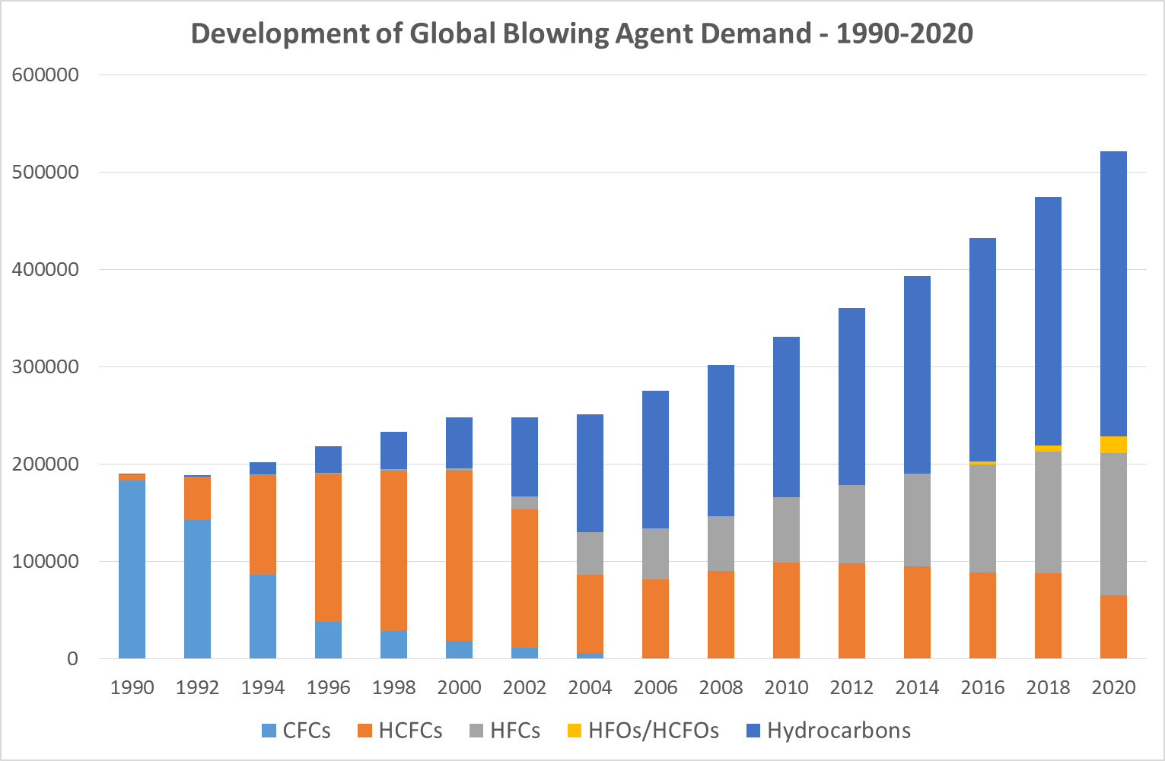 Source: FTOC
Figure ES-1: Growth in the use of Physical Blowing Agents by Type over the period from 1990 to 2020

Overview of Progress and Challenges related to Blowing Agent Transitions

The major blowing agent transitions being driven by regulation currently are those in Article 5 parties resulting from Decision XIX/6 and being funded under national HCFC Phase-out Management Plans (HPMPs). First phase HPMP implementation is generally running smoothly, although there have been delays in the initiation of some plans owing to the significant administration involved. Since Decision XIX/6 requires a “worst first” approach, the phase-out of HCFC-141b has been particularly targeted over the period covered by this report. This has been broadly successful within larger enterprises where the critical mass of the operation is sufficient to justify investment in hydrocarbon technologies, often with individual enterprises being willing to co-fund the investment where the funding thresholds available under the Multilateral Fund have been insufficient.

Foams manufactured using other blowing agents, notably extruded polystyrene (XPS), have not typically been part of the first phase of most HPMPs. This is because there are no proven low-GWP alternatives to HCFC-142b/22 currently available. Although CO₂ technology is prevalent in Europe, it is still not clear whether it is sufficiently versatile for the variety of manufacturing plants operating in Article 5 parties. Other alternatives include hydrocarbons and ethers, but the flammability of these blowing agents is problematic when coupled with polystyrene itself which is also facing reformulation of brominated flame retardants. The situation has been further compounded in Asia since 2010 by a series of significant fires associated with insulation which have taken place during the construction phase of some high-rise buildings. Despite these concerns, investment in XPS manufacturing capacity has spiralled in response to increased demand for inexpensive and effective insulation. This has particularly been the case in Russia, the Middle East and parts of Eastern Europe and North Africa. The current choice of blowing agent in these regions are blends of HFC-134a/HFC-152a - not ideal for the climate, since these have relatively high GWP and the manufacturing process is typically quite emissive. There may be some hope that blends based on a combination of hydro fluoro olefins (HFOs) and/or hydro chloro fluoro olefins (HCFOs) together with hydrocarbons or ethers may ultimately satisfy the process and product requirements of XPS, but the continuing uncertainty is causing delay on conversions under relevant HPMPs. The net impact of these trends is projected in the Figure ES-2 below:

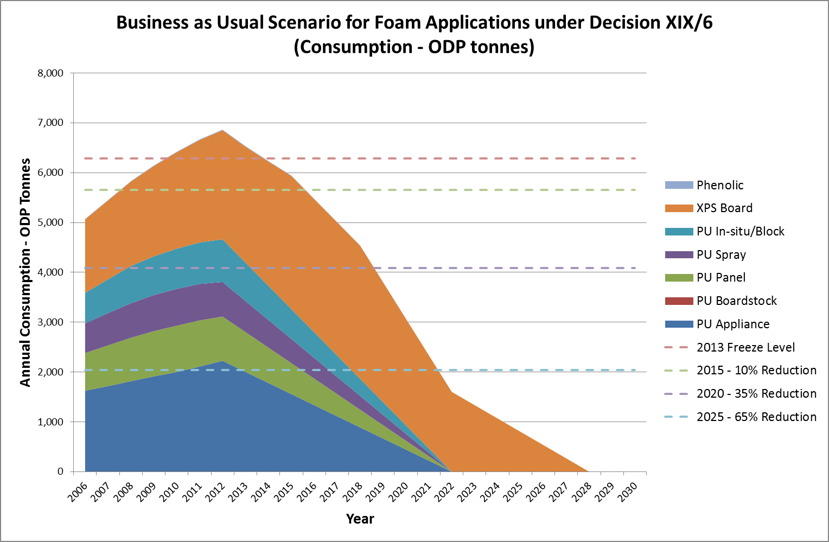

Figure ES-2: Evolution of consumption patterns for blowing agents in Article 5 Parties with time
The growth in XPS can be seen as potentially responsible for a breach of the 2013 Freeze – at least for the foams sector. However, this does not automatically mean that parties will be non-compliant with the Protocol, since there is always the potential to compensate in other sectors.

The other major factor that threatens the smooth phase-out of blowing agents is dealing with the challenge of small medium enterprises (SMEs). Lack of economies of scale prevents the adoption of hydrocarbons, while the adoption of high GWP alternatives results in high climate impact within processes which are typically less well engineered or are unavoidably emissive. Although transitions from HCFCs to HFCs were largely unavoidable in many non-Article 5 parties during phase-out of HCFCs, there is increasing pressure to switch to low-GWP technologies. In view of hydrocarbon flammability, the focus is on the potential role of less flammable blowing agents such as HFOs/HCFOs or all water-blown formulations. For integral skin, oxygenated hydrocarbons such as methyl formate and methylal are becoming the blowing agent of choice while the major PU Spray Foam markets of the USA and Canada, look likely to adopt HFOs/HCFOs, with commercial systems now beginning to emerge.

Non-Article 5 parties in North America, Europe and Japan are now pursuing regulatory strategies to encourage the phase-out of HFC use in the foam sector. In Europe, this has been enacted under the re-cast F-Gas Regulation, while in the USA, the existing Significant New Alternatives Program (SNAP) is being explored as a tool for the de-selection of some blowing agent options. These regulatory initiatives could place particular pressure on the XPS industry in these regions, since universally acceptable alternatives are still to emerge. In Japan, GWP limits have been set on PU Spray foam from 2020 and reporting requirements continue for HFC-245fa and HFC-365mfc.

Update on Bank Estimates and Emerging Management Strategies

Global banks of blowing agents in foams are estimated to have grown from around 3 million tonnes in 2002 to an estimated 4.45 million tonnes in 2015. Based on current consumption estimates, these will grow to well in excess of 5 million tonnes by 2020. However, a significant proportion of this bank will already have moved into the waste stream (typically landfill) by then. To deter this, ODS-containing foam is being increasingly treated as hazardous waste, but policing shipments is difficult when no simple way of determining foam blowing agent exists. The search for appropriate detection equipment continues for both the characterisation of waste and the monitoring of cross-border trade. A further option is to encourage voluntary intervention at decommissioning by assigning value to the process. Although climate benefits are the focus, the average global warming potential (GWP) of the waste stream will decrease with time as the average GWP decreases. Figure ES-3 illustrates this trend:

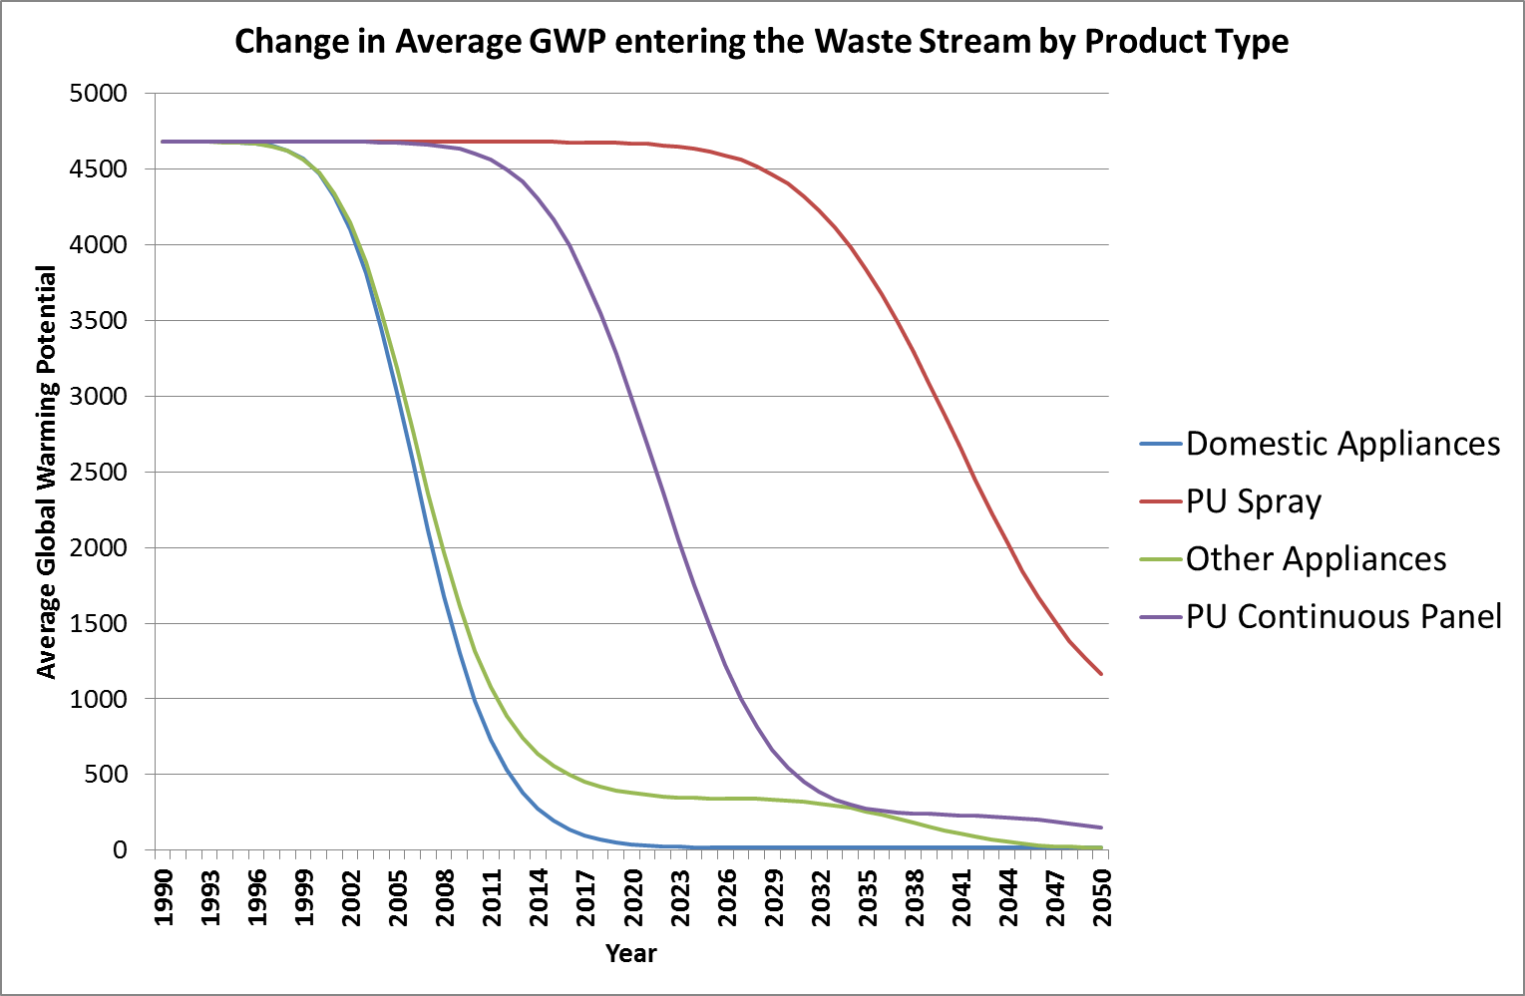
Figure ES-3: Expected decline in average GWP of the waste streams for typical foam applications
These trends imply that there is an urgent need to introduce effective waste management practices. Indeed, much of the climate benefit arising from appliances foams has already passed. This is being borne out in practice for many appliance recycling plants, where the associated climate benefit cannot now be relied upon as a justification for investment. As a result contractors are looking to minimise their upfront investment costs by adopting manual dismantling practices, even though there are associated emissions. This is especially the case in areas of low population density, where the economies of scale are more limited.

Trends in Global Foam Use and impacts on Blowing Agent Consumption

Growth in Global Foam Use

The global economic recession of 2008/9 has had some significant impact on investment within the construction sector since 2010, particularly in non-Article 5 parties. The project lead times associated with new-build construction projects (typically 2-3 years from initiation to completion) has meant that recovery of new construction activities has only really surfaced in 2012/13. However, investment in new construction in Article 5 countries has continued broadly unabated. This is indicated in the Figure 1 below:

Source: IHS Global Insight

Figure 1: Growth in Construction Spending 2010/11 vs 2012/13 (%)

Building renovation projects in Europe have been less affected during the period, partly because their lead times are shorter and partly because the investments are lower in magnitude. Typically, Article 5 parties are focused primarily in new construction, while non-Article 5 parties are increasingly turning to renovation strategies. This is partly a recognition that, in most non-Article 5 parties, over 50% of the buildings that will be operational in 2050 have already been built. If impacts on building energy efficiency and related CO₂ emissions are going to be made, then significant renovation programmes will be required.

In both new construction and renovation, the demand for thermal insulation has increased substantially as the role of buildings in reducing energy dependency and greenhouse gas emissions has been recognised. New or improved thermal insulation requirements have emerged across the Middle East and throughout India, China, South Africa and Latin America. Although there has been some shifting between fibre and foam market shares in China during the period, partially as a result of a temporary moratorium on the installation organic insulation materials (including polyurethane and polystyrene) arising from fire concerns, the production of polyurethane chemicals globally has grown by 8.8% over the same time period to just under 18 million tonnes. Figure 2 illustrates the geographic spread of this production and indicates the growing importance of Article 5 regions in both the production and consumption of polyurethane chemicals.

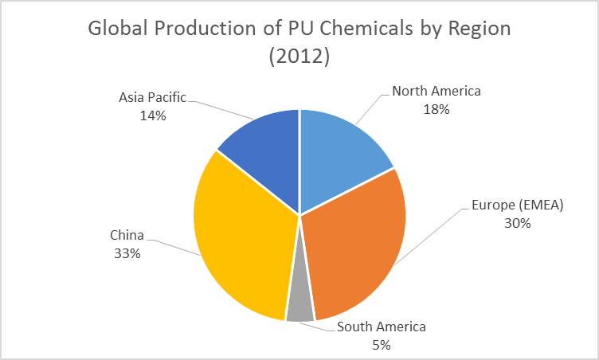

Source: PU Magazine

Figure 2: Regional Distribution of PU Chemical Production in 2012 (~18 million tonnes)

Impact on Blowing Agent Consumption

Of the total polyurethane production, 9.7 million tonnes is estimated to be consumed in the foam sector annually with approximately 5.9 million tonnes being in the rigid insulation foam sector, where it consumes blowing agents of interest to the Montreal Protocol. Other competing foam insulation materials are Expanded Polystyrene (never used ozone depleting substances), Extruded Polystyrene (XPS), phenolic and polyethylene foams. XPS foams are understood to consume approximately 1.25 million tonnes of polystyrene globally. Based on average blowing agent percentages of 5.5% w/w for polyurethane and 4.5% w/w for XPS, this leads to an estimated demand of approximately 380,000 tonnes between them with a further 10,000 tonnes being consumed by other foam types.

Projection of Business-as-Usual Trends to 2020

Current polymer foam projections suggest on-going growth to 2019 of an average of 4.8% per year, which is slightly more rapid than the 4.4% per year achieved in the period 2009-2014. On this basis global blowing agent consumption can expect to exceed 520,000 tonnes by 2020 unless there are further gains in blowing efficiency as technologies develop. Based on trends in blowing agent selection monitored by the Foams Technical Options Committee, the historic, current a future demand for physical blowing agents is summarised in Figure 3 below:

Source: FTOC

Figure 3: Growth in the use of Physical Blowing Agents by Type over the period from 1990 to 2020

Overview of Progress and Challenges Related to Blowing Agent Transitions

Progress with HCFC Phase-out Management Plans (HPMPs) in the Foam Sector

The major blowing agent transitions being driven by regulation at present are those in Article 5 parties resulting from the enactment of Decision XIX/6 and being funded under a series of national HCFC Phase-out Management Plans (HPMPs). HPMPs are currently in their first phase and implementation is generally running smoothly, although there have been delays in the initiation of some plans owing to the significant administration involved. Since Decision XIX/6 requires a “worst first” approach, the phase-out of HCFC-141b has particularly been targeted over the period covered by this report. This has been largely successful within larger enterprises where the critical mass of the operation is sufficient to justify investment in hydrocarbon technologies. Indeed, in several instances, individual enterprises have been willing to co-fund the investment where the funding thresholds available under the Multilateral Fund have been insufficient, despite the economies of scale.

Particular Challenges with PU Spray Foams and Extruded Polystyrene

For PU Spray foam the major challenge relates to the safe processing of these systems under in-situ conditions within a building. The potential for the accumulation of blowing agent in ‘pockets’ creates the risk of fire or explosion if flammable materials are used. Therefore, hydrocarbons have broadly been ruled out for these applications. This has led to the retention of HCFC-141b as a blowing agent in Article 5 parties, while formulators and contractors have switched to high-GWP HFCs such as HFC-245fa and HFC-365mfc/227ea in non-Article 5 parties, where HCFCs have already been phased out.

Foams manufactured using other blowing agents, notably extruded polystyrene (XPS) which uses HCFC-142b, HCFC-22 or blends thereof, have not typically been part of the first phase of most HPMPs. Apart from the fact that the ozone depletion potentials (ODPs) of the blowing agents are lower than for HCFC-141b, there are no obvious alternatives currently available. Although CO₂ technology is prevalent in Europe, it is still not clear whether this will be sufficiently versatile to be used in the variety of manufacturing plants operating in Article 5 parties. Other alternatives include hydrocarbons and ethers, but the flammability of these blowing agents is viewed by many as problematic when coupled with a polystyrene matrix which is also facing reformulation of flame retardants following the action being taken on hexa-bromo-cyclo-dodecane (HBCD) under the Stockholm Convention. The situation has been further compounded in Asia since 2010 by a series of significant fires associated with insulation which have taken place in high-rise buildings (typically during the construction phase). Despite these concerns, investment in XPS manufacturing capacity has continued to spiral as demand for inexpensive and effective insulation has increased. This has particularly been the case in Russia, the Middle East and parts of Eastern Europe and North Africa. The current choice of blowing agent for these new installations, as well as for the existing ones, are blends of HFC-134a/HFC-152a. This is not an ideal choice for the climate, since these blends have relatively high Global Warming Potential (GWP) and the manufacturing process for XPS is relatively emissive. There may be some hope that blends based on a combination of hydro fluoro olefins (HFOs) and/or hydro chloro fluoro olefins (HCFOs) together with hydrocarbons or ethers may ultimately satisfy the process and product requirements of XPS, but the continuing uncertainty is certainly causing delay on conversions under relevant HPMPs. The net impact of these trends is projected in the Figure 4 below:

Figure 4: Evolution of consumption patterns for blowing agents in Article 5 Parties with time

The growth in XPS can be seen as potentially responsible for a breach of the 2013 Freeze – at least for the foams sector. However, this does not automatically mean that parties will be non-compliant with the Protocol, since there is always the potential to compensate in other sectors. Nevertheless, the significance of the XPS challenge is self-evident.

Enterprise Size and Economies of Scale

The other major factor that threatens the smooth phase-out of blowing agents in both Article 5 and non-Article 5 parties is the challenge of dealing with a multitude of small medium enterprises (SMEs). In these instances, the lack of economies of scale does not allow for the adoption of hydrocarbons, while the adoption of high GWP alternatives such as HFCs will result in high levels of emission within processes which are either less well engineered or are unavoidably emissive because they are used in-situ (e.g. PU Spray Foams). Although transitions from HCFCs to HFCs were largely unavoidable in many non-Article 5 jurisdictions at the time of phase-out of HCFCs, there is increasing pressure now to switch to low-GWP technologies. With hydrocarbons being problematic from a safety perspective, the focus is on the potential role of less flammable blowing agents such as HFOs/HCFOs or all water-blown formulations. In some specific market niches such as integral skin, oxygenated hydrocarbons such as methyl formate and methylal are becoming the blowing agent of choice. In the major PU Spray Foam markets of the USA and Canada, there are increasing signs that HFOs/HCFOs may have a significant role to play, with commercial systems now beginning to emerge.

Drivers for reducing Saturated HFC use in Non-Article 5 Parties

Non-Article 5 parties in North America, Europe and Japan are now actively pursuing regulatory strategies to encourage the phase-out of HFC use in the foam sector, wherever possible. In Europe, this has been enacted under the re-cast F-Gas Regulation, while in the USA, the potential to utilise the existing Significant New Alternatives Program (SNAP) is being explored as a tool for the de-selection of some blowing agent options. These regulatory initiatives could place particular pressure on the XPS industry in these regions, since universally acceptable alternatives are still to emerge.

Summary

In summary, while HCFC phase-out and HFC avoidance are being pursued in tandem, the more challenging areas are yet to be fully tackled. Much still depends on the future availability and cost of low-GWP blowing agents. One encouraging factor, particularly with HFOs/HCFOs, is that the thermal performance of the foams is, as a minimum, retained and in many cases improved over the HCFCs and HFCs that they are likely to replace. The commercialisation plans for these blowing agents remain on track and the next 2-3 years should confirm acceptability within the various foam sectors.

Low-GWP Alternatives by type and their significance in the Foam Sector

Broadening acceptance of Hydrocarbons

The availability of hydrocarbons at an early stage of the transition from CFCs has made it that a genuine low-GWP and cost-effective alternative has been available for large parts of the foam sector throughout that period, even at the time of the phase-out of CFCs in non-Article 5 Parties. Therefore, the account of the transition history since 1987 in the polyurethane and phenolic product sectors is dominated by whether a specific foam sub-sector could adopt hydrocarbon technologies or not. There have been a number of reasons cited over the period to explain why hydrocarbon solutions were not appropriate. These have included:

- The flammability risks associated with the production/deposition process
- The flammability risks associated with product installation and use
- The higher gaseous thermal conductivity leading to poorer thermal efficiency of the foam
- The cost of flame-proofing measures for production processes in relation to the size of the manufacturing plant (lack of economies of scale)
- Local health & safety regulations
- Local regulations on volatile organic compounds (VOCs)
- Waste management issues
Some of these have largely been discounted in more recent times, but others continue to be of importance and some are even growing in significance (e.g. waste management issues) as hydrocarbon blown foams reach end-of-life. Nevertheless, the market penetration of hydrocarbon technologies has had a substantial impact as shown in Figure 5 below:

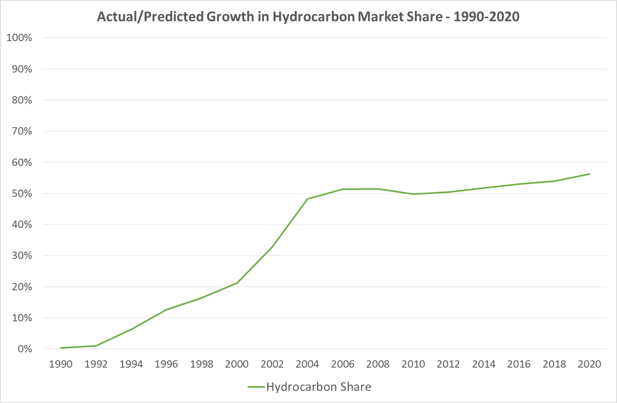

Figure 5: Evolution of market share of foam sector met by hydrocarbons

The slight stall in the growth of market share in hydrocarbon blowing agent in the period 2008-2010 has occurred as a result of growth in non-dependent foam types such as extruded polystyrene. However, hydrocarbons are still expected to play an increasing role in the period to 2020 as means are found to cost-effectively engineer hydrocarbon solutions for medium-sized enterprises.
The dominance of the hydrocarbon technologies is even greater than it appears from the graph, since the blowing efficiency of hydrocarbon blowing agents is considerably better than the CFCs and HCFCs that were replaced. This means that the amount of foam blown by the 290,000-295,000 tonnes of hydrocarbons predicted to be used in the foam industry in 2020 will be 30-40% greater than would be achieved by the same quantity of CFCs. The optimisation of hydrocarbon technologies over the years has also resulted in improvements in thermal performance through improved cell structure, thereby negating some of the earlier concerns about poorer thermal efficiency.

Carbon Dioxide as a blowing agent

Although carbon dioxide (CO₂) is generated as a by-product of the reaction between isocyanates and water in polyurethane chemistry (so called CO₂ (water) technology), the main focus of this section is on the external addition of gaseous CO₂ as a blowing agent. This is particularly a technology practiced in the Extruded Polystyrene sector, where the main low-GWP and cost-effective alternative has been CO₂ injected into the extruder itself. Again, the main challenge throughout has been to understand why this solution could not be universal in its application. Reasons have included:

- Processing difficulties with CO₂ and even CO₂/HCO or CO₂/HC blends
- The higher gaseous thermal conductivity leading to poorer thermal efficiency of the foam
- Costs of conversion - including licensing constraints resulting from patents
- Loss of processing flexibility ruling out some board geometries completely
For these reasons considerable proportions of the extruded polystyrene (XPS) industry have remained using HCFCs and HFCs rather than CO₂. This has been particularly the case in North America where the product requirements are for wide and thin boards to meet the residential sheathing market. By contrast, much of the European XPS market is targeted at requirements, such as floor insulation, where its moisture resistance is particularly valuable. In these applications, board geometries are less critical.

Injected (super-critical) CO₂ is also used for PU Spray Foam applications – most notably in Japan, where PU Spray Foam is widely used. The technology is proprietary to one company and this has arguably limited its adoption on a wider basis. There are also some short-comings in thermal performance against other technological solutions in the sector, especially in relation to the emerging unsaturated fluorocarbons (see next section).

Latest Status of Unsaturated HFC/HCFC Developments

In recent years, the search for low-GWP, high performance blowing agents without the limitations of hydrocarbons and CO₂ has been continuing. For the first time, the emergence of unsaturated HCFCs and HFCs (often commercially referred to as HFOs) seems to be offering a level of performance which not only allows the replacement of blowing agents with high-GWPs such as HCFCs and saturated HFCs, but also has the potential to replace some elements of the hydrocarbon and CO₂-blown sectors, based primarily on improved thermal properties. This is particularly the case in the PU Appliance sector, where at least three Asian manufacturers have already adopted HFO technology alongside their non-Article 5 competitors. In practice, and for cost reasons, blends of HFOs with other blowing agents are likely to be favoured. Although the situation is becoming clearer with these technologies, there are still some uncertainties over the overall system cost and the global availability. Commercial availability has already been established for HFO-1234ze(E) (gaseous blowing agent) and HFO-1233zd(E) (liquid blowing agent). Pilot scale production of HFO-1336mzzm(Z) commenced in late 2014, with full commercialisation expected in 2016. However, for all of these options availability is likely to be targeted mostly in markets where the requirement for improved thermal efficiency is best identified. In addition, the demand to leap-frog high GWP HCFC alternatives in other sectors could further accelerate distribution in Article 5 regions. This is especially the case in the rapidly growing XPS sector where the emergence of gaseous unsaturated HFCs such as HFO-1234ze presents a significant opportunity to replace any remaining HCFCs, saturated HFCs and even CO₂ in some instances. However, cost remains a key issue and blending with oxygenated hydrocarbons (e.g. dimethyl ether) may well be required to deliver a commercially viable alternative technology.

Progress with other Low GWP Alternative Blowing Agents

Other blowing agents are also emerging as potential replacements for HCFCs and HFCs. These include a group of oxygenated hydrocarbons (HCOs) which include methyl formate and methylal. These are generally seen as less flammable than the hydrocarbons themselves, although the significance of those differences can often depend on local product codes and the regulatory frameworks governing foam manufacture. Again, there is a growing tendency to see these used as components of tailored blends where they can contribute to overall performance criteria.

In summary, Table 1 provides an overview of the blowing agent classes which have either been previously offered, or are currently being offered, alternatives to ozone depleting substances in the sectors being specifically considered in this report. The table has been simplified over that of previous years by the fact that the Arkema product previously described as AFA-1 has now been confirmed as HFO-1233zd(E), which aligns it with the existing Honeywell product.

Sector | CFCs | HCFCs | HFCs | HCs | HCOs | HFOs | CO₂-based
 | ODS being replaced
PU Appliances | CFC-11 | HCFC-141b  HCFC-22 | HFC-245fa  HFC-365mfc/227ea | cyclo-pentane  cyclo/iso-pentane | Methyl^{Δ} Formate | HFO-1233zd(E)  HFO-1336mzzm(Z) | CO₂ (water)*^{Δ}
PU Board | CFC-11 | HCFC-141b | HFC-365mfc/227ea | n-pentane  cyclo/iso pentane |  | HFO-1233zd(E)  HFO-1336mzzm(Z)
PU Panel | CFC-11 | HCFC-141b | HFC-245fa  HFC-365mfc/227ea | n-pentane  /iso pentane |  | HFO-1233zd(E)  HFO-1336mzzm(Z) | CO₂ (water)*
PU Spray | CFC-11 | HCFC-141b | HFC-245fa  HFC-365mfc/227ea |  |  | HFO-1233zd(E)  HFO-1336mzzm(Z) | CO₂ (water)*  Super-critical CO₂
PU In-situ/Block | CFC-11 | HCFC-141b | HFC-245fa  HFC-365mfc/227ea | n-pentane  cyclo/iso pentane |  | HFO-1233zd(E)  HFO-1336mzzm(Z) | CO₂ (water)*
PU Integral Skin | CFC-11 | HCFC-141b  HCFC-22 | HFC-245fa  HFC-134a |  | Methyl Formate  Methylal |  | CO₂ (water)*
XPS Board | CFC-12 | HCFC-142b  HCFC-22 | HFC-134a  HFC-152a |  | DME | HFO-1234ze(E) | CO₂  CO₂/ethanol
Phenolic | CFC-11 | HCFC-141b | HFC-245fa  HFC-365mfc/227ea | n-pentane  cyclo/iso pentane |  | HFO-1233zd(E)  HFO-1336mzzm(Z)
*CO₂(water) blown foams rely on the generation of CO₂ from reaction of isocyanate with water in the PU system itself
^{Δ} Primarily in the commercial refrigeration sector (e.g. vending machines)

Table 1: Range of blowing agents available by product type and market sector

The next section of this report now reviews these selection trends sub-sector by sub-sector.

Review of blowing agent selection by foam sub-sector and region

Polyurethane Foams in the Refrigeration Sector

Commercially available alternatives to ODS

Table 2 below gives an overview of the alternatives currently available for refrigeration applications:

HCFC REPLACEMENT OPTIONS FOR APPLIANCES (DOMESTIC & COMMERCIAL), TRUCKS & REEFERS
SECTOR/OPTION | PROS | CONS | COMMENTS
Domestic refrigerators/freezers
Cyclopentane & cyclo/iso blends | Low GWP | Highly flammable | High incremental capital costs but most enterprises in sub-sector are large
Cyclopentane & cyclo/iso blends | Low operating costs |  | Global industry standard
Cyclopentane & cyclo/iso blends | Good foam properties
Saturated HFCs (HFC-245fa) | Non-flammable | High GWP | Low incremental capital costs
Saturated HFCs (HFC-245fa) | High operating costs |  | Improved insulation (cf. HC)
Saturated HFCs (HFC-245fa) | Good foam properties |  | Well proven technology
Commercial refrigerators/freezers plus vending equipment
Cyclopentane & cyclo/iso blends | Low GWP | Highly flammable | High incremental capital cost, may be uneconomic for SMEs
Cyclopentane & cyclo/iso blends | Low operating costs |  | Well proven technology
Cyclopentane & cyclo/iso blends | Good foam properties
HFC-245fa, HFC-365mfc/227ea | Non-flammable | High GWP | Low incremental capital cost
HFC-245fa, HFC-365mfc/227ea | Good foam properties | High operating costs | Improved insulation (cf. HC)
CO₂ (water) | Low GWP | Moderate foam properties – high thermal conductivity & high foam density | Low incremental capital cost
CO₂ (water) | Non-flammable | High operating costs | Improved formulations (second generation) claim no need for density increase vs HFC co-blown
Methyl Formate | Low GWP | Moderate foam properties -high thermal conductivity & high foam density- | Moderate incremental capital cost (corrosion protection recommended)
Methyl Formate | Flammable although blends with polyols may not be flammable | High operating costs
Refrigerated trucks & reefers
Cyclopentane & cyclo/iso blends | Low GWP | Highly flammable | High incremental capital cost, may be uneconomic for SMEs
Cyclopentane & cyclo/iso blends | Low operating costs
Cyclopentane & cyclo/iso blends | Good foam properties
HFC-245fa, HFC-365mfc /227ea | Non-flammable | High GWP | Low incremental capital cost
HFC-245fa, HFC-365mfc /227ea | Good foam properties | High operating costs | Improved insulation (cf. HC)
CO₂ (water) | Low GWP | Moderate foam properties -high thermal conductivity & high foam density- | Low incremental capital cost
CO₂ (water) | Non-flammable | High operating costs | Not used in reefers
Table 2: Assessment of selection criteria for ODS alternatives in the Refrigeration Sector
The assessment of these alternatives against the criteria of commercial availability, technical proof of performance, environmental soundness (encompassing efficacy, health, safety and environmental characteristics), cost effectiveness (capital and operating) and processing versatility in challenging ambient conditions is, in itself, a challenging objective. Typically, performance against such criteria can only be judged fully on a case-by-case basis and assessments made at a higher level will only be indicative. With this in mind, the following table seeks to give such an indicative assessment based on a nominal ranking of seven categories from ‘+++’ (the best) to ‘---‘ (the worst):

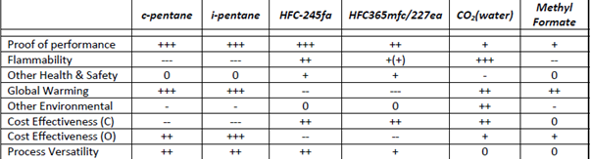
Table 3: Indicative assessment of criteria for current ODS alternatives in the Refrigeration Sector
As has been noted in previous reports, the mix of performance properties (technical, economic and environmental) does not lead unambiguously to one single selection. Indeed, the proliferation of blends across the whole of the foam sector and nowhere more so than the appliance sector is an indication of the reality that there is no single best solution. Often a key factor is the size of the manufacturing plant, since the economies of scale have a considerable bearing on the relative importance of capital and operational costs. Cost also is a major factor in the consideration of the major emerging technologies.

Emerging Alternatives

As noted in previous reports, the major emerging technologies in the appliance sector are based mostly around liquid unsaturated HCFCs/HFCs. These are all fairly similar in their properties and all seem to suggest a stepwise improvement in thermal performance over other low-GWP alternatives. HFO-1233zd (E) successfully started to be used at a major global appliance player in June 2014. Table 4 provides an overview of the ‘pros’ and ‘cons’ of these technologies.

HCFC REPLACEMENT OPTIONS FOR APPLIANCES (DOMESTIC & COMMERCIAL), TRUCKS & REEFERS
SECTOR/OPTION | PROS | CONS | COMMENTS
Domestic refrigerators/freezers
Unsaturated HFC/HCFCs (HFOs) | Low GWP | High operating costs | Successfully trialled in 2012/13 and commercial adoption now underway
Unsaturated HFC/HCFCs (HFOs) | Non-flammable |  | Improved energy efficiency performance: typically better than saturated HFCs
Unsaturated HFC/HCFCs (HFOs) |  |  | Low incremental capital cost
Commercial refrigerators/freezers plus vending equipment
Liquid Unsaturated HFC/HCFCs (HFOs) | Low GWP | High operating costs | Following domestic appliance trends with blends being adopted
Liquid Unsaturated HFC/HCFCs (HFOs) | Non-flammable |  | Improved energy efficiency performance: typically better than saturated HFCs
Liquid Unsaturated HFC/HCFCs (HFOs) |  |  | Low incremental capital cost
Refrigerated trucks & reefers
Liquid Unsaturated HFC/HCFCs (HFOs) | Low GWP | High operating costs | Although HFOs commercialised, limited case experience available
Liquid Unsaturated HFC/HCFCs (HFOs) | Non-flammable |  | Improved energy efficiency performance: typically better than saturated HFCs
Liquid Unsaturated HFC/HCFCs (HFOs) |  |  | Low incremental capital cost

Table 4: Emerging alternatives to ODS in the Refrigeration Sector
The range of unsaturated HCFCs/HFCs has been reduced from the selection provided in the Decision XXIV/7 Report. The disclosure of the molecule behind Arkema’s code name AFA-L1 occurred in September 2013, and revealed it as the same molecule being developed and commercialised by Honeywell. However, Table 5 provides an analysis of these new molecules against the criteria considered for the commercially available alternatives based on limited experience in appliance sector trials.

 | HFO-1234ze(E) | HFO-1336mzzm(Z) | HFO-1233zd(E)
 | Gaseous | liquid | liquid
Proof of performance | + | ++ | ++
Flammability | ++ | +++ | +++
Other Health & Safety | + | + | +
Global Warming | +++ | +++ | +++
Other Environmental | + | + | +
Cost Effectiveness (C) | ++ | ++ | ++
Cost Effectiveness (O) | -- | -- | --
Process Versatility | + | + | +

Table 5: Indicative assessment of criteria for emerging ODS alternatives in the Refrigeration Sector
As noted above, the commercialisation time-line and global availability of the various unsaturated HCFCs/HFCs will have a considerable bearing on their widespread adoption under the HCFC Phase-out Management Plans currently being enacted. Two of the three potential manufacturers are committing to timelines of 2015 or better, but the supply/demand curves for these alternatives are still not fully understood. As noted earlier, one major manufacturer has started up global scale plants for both gaseous and liquid HFOs in the last two years.

One factor in the adoption of these new technologies is the potential use of blends of unsaturated HFCs/HCFCs with hydrocarbons to achieve intermediate thermal performance benefits at affordable cost. If the compromises made are too great, then the benefits will be too marginal to justify transition from existing hydrocarbon solutions where they are already in place, and to prefer unsaturated HCFC/HFC solutions over hydrocarbon where they are not. However, with the cost of these new compounds not completely established at this point, it is not clear whether solutions maximising the thermal performance benefits will be affordable.

For those still using HCFC-141b, one strategy being considered in the case of some manufacturers is to make an intermediate transition to a high-GWP (lower investment) technology option such as saturated HFCs on the written understanding that a further transition to a low-GWP option will follow within a specified period. The choice would be left open until such time as optimum technology approaches have been established.

For transitions directly from HCFC-141b to hydrocarbons, there are potential strategies to reduce the investment costs for smaller enterprises. These include the potential for using pre-blended mixes containing cyclo-pentane. However, this approach is not expected to impact the domestic appliance sector too greatly, since economies of scale would generally support a more comprehensive conversion strategy. However, in the case of some manufacturers of commercial appliances (e.g. vending machines), there may be more relevance.

Non-Article 5 Parties

In Europe and Japan, the dominant blowing agent choices have been hydrocarbon blends, even at the point of phase-out from CFC use in the early/mid 1990s. Cyclo-pentane was a favoured component of blends because of its contributions to improved thermal performance and its higher boiling/flash point. However, its lack of blowing efficiency in pure form and the impact of this on processing and cost often led to the blending with components such as iso-pentane or n-pentane. Therefore, cyclo-iso blends have been a common feature of the domestic appliance industry and still remain so.

In North America, the technology choice was driven in a different direction – partly by the overall size and design of refrigerators and partly because of safety and insurance concerns from a manufacturing perspective. Transitions from CFCs moved to HCFCs and then, primarily, to HFC-245fa. There has also been some use of HFC-134a in the sector and, more recently, the removal of patent restrictions has allowed for the introduction of HFC-365mfc/227ea blends. Therefore, the domestic appliance industry in this region remains largely dependent on high GWP HFCs.

For commercial appliances and more complex insulated containers, the blowing agent choices have been more varied, with greater reliance on lower flammability options. In some instances (e.g. in vending machines), this has encouraged the use of oxygenated hydrocarbons such as methyl formate and, to a lesser degree methylal. In addition, there has been widespread reliance on HCFCs and, more latterly high GWP HFCs.

Although there are no obvious pressures to change technologies in any of the regions referenced above, the emergence of unsaturated HFCs and HCFCs has generated particular interest in all regions. The main reason is that these molecules offer improved thermal insulating properties in an application where maximising thermal performance and minimising insulation thickness are desirable outcomes. Whether additional market pressures in North America relating to the continued use of high-GWP HFCs will add to the pressure to adopt blends containing the unsaturated molecules is not yet clear.

Article 5 Parties

Similar trends exist for in the highly populated Article 5 Parties where multi-national companies are often seeking to adopt global technology strategies. In some cases, the transition from HCFCs to alternatives has not yet occurred and there are opportunities to avoid high-GWP HFCs. However, the Multilateral Fund process does not direct influence over these technology choices, since funding is usually not provided. Instead it falls on individual Parties to negotiate a phase-out strategy with their industries. This matter is covered further in Chapter 4. Interest in unsaturated HFCs and HCFCs is expected to mirror the decisions made in non-Article 5 regions.

For those transitions covered under the Multilateral Fund, it has been possible to direct virtually all HCFC phase-out activities towards low-GWP alternatives including pre-blended hydrocarbon, methyl formate and methylal. Transitions will not be complete before 2015, at which point the full degree of coverage of these technologies will be more self-evident.

Polyurethane Boardstock

This is one of the largest markets for rigid polyurethane foams in non-Article 5 Parties, but has only recently started to grow significantly in Article 5 Parties as requirements for building energy efficiency have increased. The historical analysis therefore focuses primarily on the non-Article 5 experiences.

Commercially available alternatives to ODS

Table 6 below gives an overview of the alternatives currently available for boardstock applications

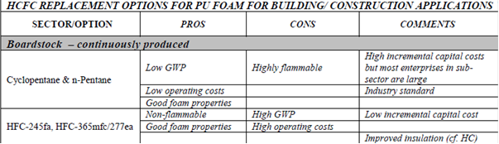

Table 6: Assessment of selection criteria for ODS alternatives in the Boardstock Sector
In general, saturated HFCs have shown little uptake in most PU Boardstock markets because the hydrocarbon-based products have been shown to be fit-for-purpose at a more competitive cost. Since new capacity in the industry can accommodate hydrocarbon process safety issues at the design stage, the high incremental capital costs associated with later transitions can be mitigated to some extent.

As building energy standards increase, there could be increasing pressure for better thermal efficiency, especially where space is limited and product thickness is constrained. There has therefore been some interest in possible blends of hydrocarbons with saturated HFCs. Indeed, it is suspected that some manufacturers may have adopted this strategy commercially, although it is difficult to track because no further plant modifications would normally be necessary. Such trends may also be short-lived, since there is increasing market pressure (e.g. through LEED and other environmental building schemes) to avoid the use of saturated HFCs.

According to the chosen criteria, the relative performance of alternative technology solutions in this sector can be summarised as follows:

 | c-pentane | n-pentane | i-pentane | HFC-245fa | HFC365mfc/227ea
Proof of performance | +++ | +++ | +++ | ++ | ++
Flammability | --- | --- | --- | ++ | +(+)
Other Health & Safety | 0 | 0 | 0 | + | +
Global Warming | +++ | +++ | +++ | -- | ---
Other Environmental | - | - | - | 0 | 0
Cost Effectiveness (C) | -- | -- | -- | ++ | ++
Cost Effectiveness (O) | ++ | +++ | +++ | -- | --
Process Versatility | ++ | ++ | ++ | ++ | +

Table 7: Indicative assessment of criteria for current ODS alternatives in the Boardstock Sector
The slight environmental concerns reflected for hydrocarbon options relate to some emerging concerns about local VOC regulations. In some regions there are exemptions for thermal insulation manufacturing plants, but this approach is not universal.

Emerging Alternatives

The market pressure on saturated HFCs outlined in the previous section opens up the possibility for hydrocarbon blends with unsaturated fluorocarbons (both HCFCs and HFCs). The uncertainty of cost makes this option even less clear cut for PU Boardstock than it is for domestic appliances. Nonetheless, there continues to be sufficient interest in the option to justify its inclusion in this section as an emerging technology – albeit as a blend with hydrocarbons.

HCFC REPLACEMENT OPTIONS FOR PU FOAM FOR BUILDING/ CONSTRUCTION APPLICATIONS
SECTOR/OPTION | PROS | CONS | COMMENTS
Boardstock – continuously produced
Liquid Unsaturated HFC/HCFCs (HFOs) | Low GWP | High operating costs | With blowing agent costs a high % of overall system costs, blends are essential
 | Non-flammable |  | Successfully trialled, particularly with  blends. Re-standardisation underway.
 |  |  | Low incremental capital cost

Table 8: Emerging alternatives to ODS in the Boardstock Sector
The overall assessment of the criteria for unsaturated HCFCs/HFCs is very similar to that shown for PU appliances.

 | HFO-1234ze(E) | HFO-1336mzzm(Z) | HFO-1233zd(E)
 | Gaseous | Liquid | Liquid
Proof of performance | + | ++ | ++
Flammability | ++ | +++ | +++
Other Health & Safety | + | + | +
Global Warming | +++ | +++ | +++
Other Environmental | + | + | +
Cost Effectiveness (C) | ++ | ++ | ++
Cost Effectiveness (O) | -- | -- | --
Process Versatility | + | + | +

Table 9: Indicative assessment of criteria for emerging ODS alternatives in the Boardstock Sector
The only potential difference is that the use of a gaseous option being used in the PU Appliances sector is less likely than for PU Boardstock. Nevertheless, it has been retained for completeness.

In practice, the quantity of PU Boardstock foam still using HCFCs is very limited and this fact alone testifies to the lack of barriers to appropriate transition. As noted earlier, much of the new capacity in the sector has been installed since the ozone issue emerged and the necessary requirements for hydrocarbon have typically been designed in.

The only likely transition pressure now emerging relates to the on-going goal of improved thermal efficiency. The major barrier to the adoption of blends of saturated HFCs with hydrocarbons is market pressure, while the potential barrier to the wider use of unsaturated HCFCs/HFCs is one of cost and, in the short term, availability.

Non-Article 5 Parties

In virtually all non-Article 5 regions, hydrocarbons (typically a mixture of cyclo-pentane and iso-pentane) have been the dominant choice of blowing agent in the replacement of ozone depleting substances. Accordingly, this is reflected in the Business-As-Usual scenario used for this report. There may be some future interest in the evaluation of unsaturated HCFCs/HFCs, but the cost is likely to be prohibitive in this cost sensitive application unless space saving is at a premium.

Article 5 Parties

There is no significant manufacture of boardstock in Article 5 regions with the possible exception of China. However, where new capacity is installed, it is highly likely that the blowing agent of choice will once again be hydrocarbons.

Polyurethane Panels

In the context of this analysis, the primary panels being referred to are steel-faced and either continuously or discontinuously produced. The market for such panels has developed very differently in various regions of the world, with the early adoption being mostly in Europe. However, the prefabricated approach to building that these panels allow is becoming increasingly widespread globally and manufacturing capacity has continued to grow to meet the need.

Commercially available alternatives to ODS

Table 10 provides an overview of the commercially available alternatives in both the continuous and discontinuous panel sectors:

HCFC REPLACEMENT OPTIONS FOR PU FOAM FOR BUILDING/ CONSTRUCTION APPLICATIONS
SECTOR/OPTION | PROS | CONS | COMMENTS
Steel-faced panels – continuously produced
Cyclopentane & n-Pentane | Low GWP | Highly flammable | High incremental capital costs but most enterprises in sub-sector are large
Cyclopentane & n-Pentane | Low operating costs |  | Industry standard
Cyclopentane & n-Pentane | Good foam properties
HFC-245fa, HFC-365mfc/227ea | Non-flammable | High GWP | Low incremental capital cost
HFC-245fa, HFC-365mfc/227ea | Good foam properties | High operating costs
HFC-245fa, HFC-365mfc/227ea |  |  | Improved insulation (cf. HC)
Steel-faced panels – discontinuously produced
Cyclopentane & n-Pentane | Low GWP | Highly flammable | High incremental capital cost, may be uneconomic for SMEs
Cyclopentane & n-Pentane | Low operating costs
Cyclopentane & n-Pentane | Good foam properties
HFC-245fa, HFC-365mfc/227ea, HFC-134a | Non-flammable | High GWP | Low incremental capital cost
HFC-245fa, HFC-365mfc/227ea, HFC-134a | Good foam properties | High operating costs | Improved insulation (cf. HC)
CO₂ (water) | Low GWP | Moderate foam properties -high thermal conductivity- | Low incremental capital cost
CO₂ (water) | Non-flammable
Methyl Formate/Methylal | Low GWP | Moderate foam properties - high thermal conductivity- | Moderate incremental capital cost (corrosion protection recommended)
Methyl Formate/Methylal | Flammable although blends with polyols may not be flammable

Table 10: Assessment of selection criteria for ODS alternatives in the PU Panel Sector

The pressure for improved thermal performance in the architectural (cladding) panel is less pronounced than it is for other building insulation types because of the structural requirements which are associated with that application. However, the same cannot be said for refrigerated transport where additional benefits in thermal performance can improve the load-carrying capacity of a vehicle. Therefore, there is on-going interest in saturated HFCs as legitimate alternatives, or at least components of blends for that application.

In the discontinuous sector, there are other potential technologies based around CO₂ (water) and HCOs such as methyl formate or methylal. These reduce the perceived risks associated with the use of hydrocarbons on discontinuous plants but do result in some compromises in foam properties including higher density and potentially poorer thermal performance. Nonetheless, they do offer low-GWP solutions in markets, which may not be too sensitive to thermal performance issues. These are all important considerations in the Article 5 context where the need to phase-out HCFCs requires the widest range of alternatives, especially for small and mixed use discontinuous panel facilities. The strengths and weaknesses of these alternatives are once again shown in the Table 11 – this time relating to the panel sector.

 | c-pentane | i-pentane n-pentane | HFC-245fa | HFC365mfc/227ea | CO₂(water) | Methyl Formate
Proof of performance | + | ++ | ++ | ++ | ++ | +
Flammability | --- | --- | ++ | +(+) | +++ | --
Other Health & Safety | 0 | 0 | + | + | - | 0
Global Warming | +++ | +++ | -- | --- | ++ | ++
Other Environmental | - | - | 0 | 0 | ++ | -
Cost Effectiveness (C) | -- | --- | ++ | ++ | ++ | 0
Cost Effectiveness (O) | ++ | +++ | -- | -- | + | +
Process Versatility | ++ | ++ | + | ++ | + | +

Table 11: Indicative assessment of criteria for emerging ODS alternatives in the PU Panel Sector

Emerging Alternatives

Again, the major emerging alternatives are unsaturated HCFCs/HFCs. In view of the relative abundance of commercially available alternatives, these blowing agents are likely to be focused on niche markets in the panel sector.

HCFC REPLACEMENT OPTIONS FOR PU FOAM FOR BUILDING/ CONSTRUCTION APPLICATIONS
SECTOR/OPTION | PROS | CONS | COMMENTS
Steel-faced panels – continuously produced
Liquid Unsaturated HFC/HCFCs (HFOs) | Low GWP | High operating costs | Cost sensitivity less significant, but thermal performance improvement also less critical
 | Non-flammable |  | Trials in progress
 |  |  | Low incremental capital cost
Steel-faced panels – discontinuously produced
Liquid Unsaturated HFC/HCFCs (HFOs) | Low GWP | High operating costs | First expected commercialization in 2013
 | Non-flammable |  | Trials in progress
 |  |  | Low incremental capital cost

Table 12: Emerging alternatives to ODS in the PU Panel Sector

In principle, unsaturated HCFCs/HFCs offer opportunities for improving thermal performance while retaining a low-GWP blowing agent. For reasons stated in respect of other foam sectors, the cost of these blowing agents is still uncertain and could prevent reliance on them in isolation. That said, the added value of a panel is certainly greater than that of boardstock, so the ability to adsorb cost could be greater in this sector. Nevertheless, the most likely approach will be the adoption of blends with hydrocarbons provided that an incremental improvement in thermal performance can be achieved. This will be particularly important for the thermally sensitive applications such as refrigerated transport. The proof of performance is at a lower level in this sector than elsewhere and this is reflected in Table 13:

 | HFO-1234ze(E) | HFO-1336mzzm(Z) | HFO-1233zd(E)
 | Gaseous | liquid | Liquid
Proof of performance | 0 | + | +
Flammability | ++ | +++ | +++
Other Health & Safety | + | + | +
Global Warming | +++ | +++ | +++
Other Environmental | + | + | +
Cost Effectiveness (C) | ++ | ++ | ++
Cost Effectiveness (O) | -- | -- | --
Process Versatility | + | + | +

Table 13: Indicative assessment of criteria for emerging ODS alternatives in the PU Panel Sector
The major barriers to the substitution of alternatives in the panel sector are not primarily related to the technologies available but to the wide range of enterprises involved (both in size and location) and the broad spectrum of applications served. Versatility is a key necessity for any technology in the discontinuous sector, but no single solution has emerged as being as versatile as the ozone depleting substances replaced. This may act as a deterrent to early phase-out of the remaining HCFC use in Article 5 enterprises where local requirements need to be matched.

Non-Article 5 Parties

For the continuous panel sector, hydrocarbons have also been the blowing agent of choice except where fire performance requirements have dictated otherwise. In these limited instances, high-GWP HFCs have been adopted. Increasingly the industry has found ways of optimising formulations to improve fire performance while still using hydrocarbons and the use of saturated HFCs has steadily decreased over the last five years. This is reflected in the Business-as-Usual scenario used for this report.

For discontinuous panel manufacture, there has been greater reliance on high-GWP HFCs as replacements for HCFCs in order to overcome flammability concerns during processing. Nevertheless, similar trends to those with continuous panels are now being observed as manufacturers become more skilled and experienced in managing hydrocarbons in production situations.

Article 5 Parties

There is a greater preponderance of discontinuous production in Article 5 regions because of the lack of concentrated demand to support continuous production facilities. This has ensured continued use of HCFCs in many small discontinuous panel manufacturing uses. Although oxygenated hydrocarbons (HCOs) such as methyl formate and methylal are also being considered for this sector, the uptake at present is still relatively low.

Polyurethane Spray

Polyurethane spray foam has been used for many years as an efficient means of insulating structures which would be difficult to insulate in other ways, because of shape or location. An example would be that of an insulated road tanker. Another would be the insulation of large flat roofs, which may not be as flat as might be presumed! More recently, however, polyurethane spray foams have emerged as a vital component of renovation strategies for existing buildings. Again, the efficiency and versatility of application, as well as the relative durability and thermal efficiency are all characteristics, which have contributed to the rapid growth of PU spray foam in both developed and developing regions.

Commercially available alternatives to ODS

The commercially available technologies have been largely referenced already in the narrative, but can be summarised as follows:

HCFC REPLACEMENT OPTIONS FOR PU FOAM FOR BUILDING/ CONSTRUCTION APPLICATIONS
SECTOR/OPTION | PROS | CONS | COMMENTS
Spray foam
Cyclopentane & n-Pentane | Low GWP | Highly flammable | Unsafe to use in this application
HFC-245fa, HFC-365mfc/227ea | Non-flammable | High GWP | Industry standard
HFC-245fa, HFC-365mfc/227ea | Good foam properties | High operating costs but improved by using mixed HFC/ CO₂ (water)
CO₂ (water) | Low GWP | Moderate foam properties -high thermal conductivity & high density- | Extra thickness leading to a cost penalty
CO₂ (water) | Non-flammable
Methyl Formate | Low GWP | Flammable although blends with polyols may not be flammable | Safety concerns when used for this application

Table 14: Assessment of selection criteria for ODS alternatives in the PU Spray Foam Sector

It is important to note that the impacts of the saturated HFCs have been reduced by co-blowing with major drivers has been to reduce cost. As will be seen later in this sub-section this may be an important approach for the future.

Methyl formate has also been used for some PU spray work. The potential of supplying the system to site as blended polyol is believed to contribute to the management of risk, but it is still unclear whether the hazards seen with hydrocarbons in confined spaces have been avoided using methyl formate. Work continues in this area, although some systems are already being used commercially. The performance of these ODS alternatives against the criteria for this report can be summarised as shown in Table 15:

 | HFC-245fa | HFC365mfc/227ea | Super-critical CO₂ | CO₂(water) | Methyl Formate
Proof of performance | +++ | +++ | ++ | ++ | +
Flammability | ++ | +(+) | ++ | +++ | --
Other Health & Safety | + | + | + | - | 0
Global Warming | -- | --- | ++ | ++ | ++
Other Environmental | 0 | 0 | + | ++ | -
Cost Effectiveness (C) | ++ | ++ | 0 | ++ | 0
Cost Effectiveness (O) | -- | -- | + | ++ | ++
Process Versatility | ++ | ++ | + | + | +

Table 15: Indicative assessment of criteria for emerging ODS alternatives in the PU Spray Sector

Emerging Alternatives

Alongside the appliance sector, the PU spray foam sector is attracting the most interest for potential adoption of the unsaturated HCFCs/HFCs. The rapid growth rate for the sector overall, the absence of serious low-GWP contenders and the fact that relatively high emission rates make the climate impact more immediate all align to encourage the manufacturers to focus on this application.

HCFC REPLACEMENT OPTIONS FOR PU FOAM FOR BUILDING/ CONSTRUCTION APPLICATIONS
SECTOR/OPTION | PROS | CONS | COMMENTS
Spray foam
Liquid Unsaturated HFC/HCFCs (HFOs) | Low GWP | High operating costs but improved by using mixed HFC/ CO₂ (water) | First expected commercialization from 2013
 | Non-flammable |  | Trials in progress
 |  |  | Low incremental capital cost

Table 16: Emerging alternatives to ODS in the PU Spray Foam Sector

The cost of the alternatives remains the key question but this consideration is slightly diffused by the fact that the CO₂ (water) technology developed around HFC-245fa and HC-365mfc/227ea looks transferable to the unsaturated blowing agents as well. Manufacturers are in the process of field trials and the development of fairly sophisticated life cycle assessments to ensure that they have assessed the environmental impacts correctly. The co-blowing solution does not detract significantly from the overall thermal performance of the foam and the introduction of a low-GWP solution of this type would clear the way for widespread use of PU spray foam in a wide variety of refurbishment applications over the next 30-50 years as global attention focuses increasingly on building energy efficiency in existing stock. However, there are emerging concerns about the potential stability of the gaseous unsaturated blowing agents in low-pressure, pre-blended formulations. This is the subject of intense further development work, but no immediate solution has so far been forthcoming. The following table has been updated accordingly.

 | HFO-1234ze(E) | HFO-1336mzzm(Z) | HFO-1233zd(E)
 | Gaseous | liquid | Liquid
Proof of performance | 0 | + | +
Flammability | ++ | +++ | +++
Other Health & Safety | + | + | +
Global Warming | +++ | +++ | +++
Other Environmental | + | + | +
Cost Effectiveness (C) | ++ | ++ | ++
Cost Effectiveness (O) | -- | -- | --
Process Versatility | + | + | +

Table 17: Indicative assessment of criteria for emerging ODS alternatives in the PU Spray Sector
Since the future of the sector rests largely on the emerging technologies, the main barriers relate to the stability, economics and availability of the unsaturated blowing agents. Much of the PU spray foam activity in China remains reliant on HCFC-141b and there is reluctance to make a transition to a sub-optimal solution when an emerging technology could out-perform it within 5 years. Various strategies are being considered including a two-step option via saturated HFCs. However, there is a need to gain commitment to the second conversion at the outset.

Non-Article 5 Parties

This remains one of the most challenging areas from a technical viewpoint, because of the processing risks associated with using hydrocarbons in field applications. As a result, HCFCs were replaced en masse by high-GWP blowing agents such as HFC-245fa (particularly in North America) and HFC-365mfc/227ea (particularly in Europe). Although unsaturated HCFCs/HFCs are seen as a future replacement, emerging concerns about the stability of the gaseous blowing agent (HFO 1234ze(E)) in certain low-pressure pre-blended formulations are placing some doubt on the ability of these technologies to reach their full potential. Accordingly, the Business-As-Usual scenario remains focused on high-GWP solutions for these low-pressure applications for the moment.

Article 5 Parties

For similar reasons to those expressed for non-Article 5 regions, PU Spray foam in Article 5 regions remains highly reliant on HCFCs. If the concerns about unsaturated HCFCs/HFCs continue for any significant period of time, contractors and systems houses may need to investigate the possibility of moving to a high-GWP interim solution in order to exit from HCFC-141b use in a timely manner.

Polyurethane In-situ/Block

One of the enduring advantages of polyurethane chemistry in general, and polyurethane foams in particular, is their ability to meet a broad range of applications. Since these applications can be diverse, ranging from cavity filling (e.g. buoyancy on leisure boats) to the fabrication of complex shapes required for pipe and flange insulation, the in-situ and block processes provide a resource to meet these needs. Self-evidently, these applications are also difficult to track in any organised way since they vary so much. Nevertheless, it is possible to track the manufacturing facilities that provide these products and services.

Commercially available alternatives to ODS

The commercially available alternatives to HCFCs in the in-situ and block sectors are summarised in Table 18:

HCFC REPLACEMENT OPTIONS FOR PU FOAM FOR BUILDING/ CONSTRUCTION APPLICATIONS
SECTOR/OPTION | PROS | CONS | COMMENTS
Insulated pipes (pipe-in-pipe for district central heating systems)and other in-situ systems
Cyclopentane | Low GWP | Highly flammable | High incremental capital cost
Cyclopentane | Low operating costs |  | Industry standard
Cyclopentane | Good foam properties
HFC-245fa, HFC-365mfc/277ea | Non-flammable | High GWP
HFC-245fa, HFC-365mfc/277ea | Good foam properties | High operating costs
CO₂ (water) | Low GWP | Moderate foam properties -high thermal conductivity-
CO₂ (water) | Non flammable
Block foams for various applications including panels, pipe insulation section, etc
Cyclopentane & n-Pentane | Low GWP | Highly flammable | High conversion costs, may be uneconomic for SMEs
Cyclopentane & n-Pentane | Low operating costs |  | Well proven technology
Cyclopentane & n-Pentane | Good foam properties
HFC-245fa, HFC-365mfc/277ea | Non-flammable | High GWP | Low conversion costs
HFC-245fa, HFC-365mfc/277ea | Good foam properties | High operating costs but improved by using mixed HFC/ CO₂ (water)
CO₂ (water) | Low GWP | Moderate foam properties -high thermal conductivity & poor ageing- | Extra thickness leading to a cost penalty
CO₂ (water) | Non flammable

Table 18: Assessment of selection criteria for ODS alternatives in the PU In-situ/Block Foam Sector

As with other thermal insulation sectors, saturated HFCs are used in block foams with a CO₂ (water) co-blowing agent to limit climate impact and also to optimise the cost/performance relationship. It has generally been found that levels of saturated HFC can be lowered in these formulations to around 50-60% of the blowing agent mix without having a detrimental effect on thermal performance. The blowing agent criteria for block and in-situ foams are shown below. In some instances, more than one rating is providing reflecting the fact that there is a disparate set of processes represented in this category.

 | c-pentane | n-pentane | HFC-245fa | HFC365mfc/227ea | CO₂(water)
Proof of performance | +/++ | +/++ | ++ | ++ | ++
Flammability | --- | --- | ++ | +(+) | +++
Other Health & Safety | 0 | 0 | + | + | -
Global Warming | +++ | +++ | -- | --- | ++
Other Environmental | - | - | 0 | 0 | ++
Cost Effectiveness (C) | -- | --- | ++ | ++ | ++
Cost Effectiveness (O) | ++ | +++ | -- | -- | +
Process Versatility | ++ | ++ | ++ | ++/+++ | +/++

Table 19: Indicative assessment of criteria for emerging alternatives in the PU In-situ/Block Sector

Emerging Alternatives

In this instance, the Foams TOC has chosen to categorise methyl formate and methylal in the emerging alternative category. This reflects the fact that some of the applications across the sector have yet to be trialled using this HCO blowing agent. There are expected to be some limitations based on densities achievable and risks of corrosion with some equipment, but the availability of a relatively low cost, low-GWP solution with lower flammability than the pentanes may still prove of relevance for the sector going forward.

HCFC REPLACEMENT OPTIONS FOR PU FOAM FOR BUILDING/ CONSTRUCTION APPLICATIONS
SECTOR/OPTION | PROS | CONS | COMMENTS
Block foams for various applications including panels, pipe insulation section, etc
HCO (Methyl Formate/Methylal) | Low GWP | Higher density required | Density increase necessary through role of MF as a solvent
Liquid Unsaturated HFC/HCFCs (HFOs | Low GWP | High operating costs | Trials in progress
Liquid Unsaturated HFC/HCFCs (HFOs | Non-flammable

Table 20: Emerging alternatives to ODS in the PU In-situ/Block Foam Sector

The option of liquid unsaturated HCFCs/HFCs in this sector is legitimate, but there is some concern that price and geographic availability may be significant limiting factors. Again, co-blowing with CO₂ (water) may prove helpful for cost reasons, but uptake is expected to be more limited than in other sectors of the foam industry. The following table shows an assessment against the report criteria:

 | Methyl Formate | HFO-1336mzzm(Z) | HFO-1233zd(E)
 |  | Liquid | Liquid
Proof of performance | 0/+ | ++ | ++
Flammability | -- | +++ | +++
Other Health & Safety | + | + | +
Global Warming | +++ | +++ | +++
Other Environmental | + | + | +
Cost Effectiveness (C) | ++ | ++ | ++
Cost Effectiveness (O) | -- | -- | --
Process Versatility | + | ++ | ++
Table 21: Indicative assessment of criteria for emerging alternatives in the PU In-situ/Block Sector
One of the major barriers to transition in this sector is the size and location of the enterprises involved. The provision of sophisticated low-GWP alternatives does not extend easily to these more diffuse networks and the effectiveness of transitions relies massively on the competence and commitment of the systems houses supplying the small and micro-enterprises. Efforts are needed to raise the profile of these operations with blowing agent technology providers and their supply networks.

Non-Article 5 Parties

These products can be made by a variety of processes, including continuous, semi-continuous and discontinuous options. Although there is some sensitivity to the use of hydrocarbons in some discontinuous facilities (see comments on discontinuous panels), the majority of products in this sector have been able to adopt hydrocarbon technologies successfully. There are possibilities that methyl formate or methylal might be able to replace saturated HFCs in some of the remaining discontinuous processes, but this will ultimately depend on local regulations and practices. Accordingly, little change is predicted in this sector within the next 5-10 years within the Business-As-Usual scenario.

Article 5 Parties

Similar concerns exist for discontinuous processes in Article 5 regions. As is the case in the panel sector, these are more prevalent in Article 5 regions because of lack of economies of scale. There are also differences in product demand with thermo-ware being a particular requirement in Southern Asia and elsewhere. For these reasons HCFCs continue to remain the blowing agent of choice, although uptake of methyl formate and/or methylal is predicted within a number of HPMPs. The magnitude of this uptake is varied in the Mitigation Scenarios selected for foams, but the Business-as-Usual scenario reflects a fairly conservative estimate of market penetration, with the remainder going to high-GWP HFCs.

Polyurethane Integral Skin

Integral skin foams are the one group of foams, which are not primarily used for thermal insulation purposes. They sub-divide into two types – ‘rigid integral skin’ (typically items such as wood replacement) and ‘flexible integral skin’ (typically covering items such as shoe soles and some packaging foams). As the name suggests, the primary feature of integral skin products is their ability to encapsulate a relatively low density core (for weight saving purposes) with an integrated skin which is made from the same material and in the same process. As a polymer, polyurethane is particularly versatile in forming a resilient skin when moulded and this provides a level of utility which is rarely seen in other product types.

Commercially available alternatives to ODS
Table 22 provides a summary of commercially available alternatives in the PU Integral Skin sector

HCFC REPLACEMENT OPTIONS FOR INTEGRAL SKIN PU FOAMS FOR TRANSPORT & FURNITURE APPLICATIONS
SECTOR/OPTION | PROS | CONS | COMMENTS
Integral skin foams
CO₂ (water) | Low GWP | Poor skin quality | Suitable skin may require in-mould-coating – added expense
CO₂ (water) | Low conversion costs |  | Well proven in application if skin acceptable
n-Pentane | Low GWP | Highly flammable | High conversion costs, may be uneconomic for SMEs
n-Pentane | Low operating costs |  | Low operating costs
n-Pentane | Good skin quality |  | Well proven in application
Shoe-soles
CO₂ (water) | Low GWP |  | Well proven in application with polyester polyol technology
CO₂ (water) | Low conversion costs
CO₂ (water) | Skin quality suitable for sports shoe mid-soles
HFC-134a or HFC-245fa | Used to give required skin in town shoes | High GWP/Cost

Table 22: Assessment of selection criteria for ODS alternatives in the PU Integral Skin Sector

The specific ranking of these blowing agent options is shown in Table 23 below.

 | n-pentane | HFC-134a | HFC-245fa | CO₂(water)
Proof of performance | ++ | ++ | + | ++
Flammability | --- | +++ | ++ | +++
Other Health & Safety | 0 | + | + | -
Global Warming | +++ | --- | --- | ++
Other Environmental | - | 0 | 0 | ++
Cost Effectiveness (C) | --- | ++ | ++ | ++
Cost Effectiveness (O) | +++ | -- | -- | +
Process Versatility | ++ | ++ | ++ | 0

Table 23: Indicative assessment of criteria for emerging alternatives in the PU Integral Skin Sector

Emerging Alternatives

The area of most interest with respect to emerging technologies is the potential use of oxygenated hydrocarbons (HCOs). Both methyl formate and methylal are being considered for these applications and the early indications are that they could be significant future alternatives in the sector. Although both flammable, there is the potential that systems houses may be able to formulate blended systems in such a way as to avoid flammability issues in the workplace. One area of concern for methyl formate is the potential corrosion of moulds, but at the levels of addition and being a fairly emissive application, this may not be a problem in practice. The other issue relating to both HCOs the high solvency power of the blowing agents which could lead to some softening of the skins. Table 24 summarises the issues.

It is noteworthy to mention that unsaturated HFCs/HCFCs are not seen as a realistic emerging technology in this sector because of the cost implications and the lack of any significant performance enhancement.

HCFC REPLACEMENT OPTIONS FOR INTEGRAL SKIN PU FOAMS FOR TRANSPORT & FURNITURE APPLICATIONS
SECTOR/OPTION | PROS | CONS | COMMENTS
Integral skin foams
Methyl formate | Low GWP | Flammable although blends with polyols may not be flammable | Moderate conversion costs
Methyl formate | Good skin quality | Moderate operating costs | Newly proven in application
Methylal | Low GWP | Flammable although blends with polyols may not be flammable | High conversion costs, may be uneconomic for SMEs
Methylal | Good skin quality | Moderate operating costs | Newly proven in application
Shoe-soles
Methyl formate | Low GWP | Flammable although blends with polyols may not be flammable | Moderate conversion costs
Methyl formate | Good skin quality | Moderate operating costs | Newly proven in application
Methylal | Low GWP | Flammable although blends with polyols may not be flammable | High conversion costs, may be uneconomic for SMEs
Methylal | Good skin quality | Moderate operating costs | Newly proven in application

Table 24: Emerging alternatives to ODS in the PU Integral Skin Sector

Again, the specific performance ranking of the blowing agents is shown in the table below:

 | Methylal | Methyl Formate
Proof of performance | + | ++
Flammability | -- | --
Other Health & Safety | 0 | 0
Global Warming | ++ | ++
Other Environmental | - | -
Cost Effectiveness (C) | + | 0
Cost Effectiveness (O) | ++ | ++
Process Versatility | +(+) | +(+)

Table 25: Indicative assessment of criteria for emerging alternatives in the PU Integral Skin Sector

There are no fundamental barriers to the introduction of the emerging technologies, although pilot projects on the pre-blending of HCOs in polyols will be necessary. There have been some concerns in the past about the implications of the limited supplier base and access to intellectual property, although these have been largely addressed. However, the biggest challenge to the replacement of any remaining use of ozone depleting substances will be the roll-out of these technologies on a sufficiently widespread basis. If the widespread introduction of HCOs can be successful, there is likely to be the gradual replacement of both saturated HFCs (HFC-134a and HFC-245fa) and CO₂(water) blown technologies. The replacement of saturated HFCs, will certain deliver some additional climate benefits.

Non-Article 5 Parties

In this non-insulating sector, CO₂(water) technologies play a significant role, particularly where skinning properties are not critical. However, in non-Article 5 regions, hydrocarbons have become increasingly accepted as reliable replacements for HCFCs that were used previously. There has been some small use of HFCs (typically HFC-134a or HFC-245fa), but this has been limited to specialist applications.

Article 5 Parties

Since the focus on technology optimisation has not been so prevalent in Article 5 regions except where multi-national clients (e.g. the automotive sector) have been involved, there has been a tendency to remain with HCFC technology while awaiting further developments. Transitions to high-GWP HFC alternatives remain the easiest technology option, although methyl formate and methylal are also appropriate options, which mitigate at least some of the flammability risks associated with other hydrocarbons. The Business-As-Usual scenario follows the path and timing of most current HPMPs in predicting the transition paths and timing.

Extruded Polystyrene Foam

Extruded polystyrene board is unique amongst the foam sectors considered in this report in that it is blown exclusively with gaseous blowing agents. This is a consequence of the extrusion process. Extruded polystyrene (XPS) should not be confused with expanded polystyrene (EPS – also sometimes called ‘bead foam’) which uses pre-expanded beads of polystyrene containing pentane. EPS has never used ozone depleting substances and is seldom addressed in UNEP Reports for the Montreal Protocol. XPS is used primarily as a building insulation and often competes with PU Boardstock. Its particular competitive advantage is in relation to its moisture resistance, which makes it especially useful for under-floor insulation and cold storage applications. There is another form of XPS known as ‘Sheet’ which is typically used for non-insulating applications such as leisure products (e.g. surf boards) and packaging materials. XPS sheet exited from CFC use early in the history of the Montreal Protocol and has used hydrocarbons almost exclusively ever since.

Commercially available alternatives to ODS

Table 26 illustrates the commercially available alternatives in the extruded polystyrene sector:

HCFC REPLACEMENT OPTIONS FOR XPS FOAM
SECTOR/OPTION | PROS | CONS | COMMENTS
Extruded Polystyrene Foams
Butane | Low GWP | Highly flammable
Butane | Low operating costs | Low thermal performance
HFC-134a/HFC-152a | Non-flammable | High GWP (but lower than HCFCs replaced)
HFC-134a/HFC-152a | Good foam properties, especially thermal performance | Medium/high operating costs
CO₂ /Ethanol/DME | Low GWP, low unit cost | Small operation window | Difficult to process especially for more than 50mm thickness board
CO₂ /Ethanol/DME | Non-flammable | Flammable co-blowing agent | Need ethanol and DME as co-blowing agent

Table 26: Assessment of selection criteria for ODS alternatives in the XPS Foam Sector

As described earlier in this section, these three alternatives describe the primary options available in each of the three main non-Article 5 regions of the world. It should be noted that blends of saturated HFCs (HFC-134a/HFC-152a) are substantially used in North America and, to a lesser extent, in Europe, primarily by smaller producers who do not have the access to CO₂ technology. Where they are used in Japan, they serve markets that cannot accept the flammability of hydrocarbon solutions. The assessment of these blowing agents via the criteria of this report is shown in Table 27:

 | butane | HFC-134a/  HFC-152a | CO₂ with ethanol or DME
Proof of performance | ++ | +++ | ++
Flammability | --- | +++ | ++
Other Health & Safety | 0 | + | +
Global Warming | +++ | -- | +++
Other Environmental | - | 0 | 0
Cost Effectiveness (C) | -- | ++ | ---
Cost Effectiveness (O) | +++ | -- | ++
Process Versatility | ++ | ++ | +

Table 27: Indicative assessment of criteria for emerging alternatives in the XPS Foam Sector

Emerging Alternatives

Table 28 sets out the most commonly cited emerging alternative for XPS Foam

- HCFC REPLACEMENT OPTIONS FOR XPS FOAM
SECTOR/OPTION | PROS | CONS | COMMENTS
Extruded Polystyrene Foams
Gaseous unsaturated HFCs (HFOs) | Low GWP | High unit cost | At least three manufacturers (all in Europe)have now adopted this technology

Table 28: Emerging alternatives to ODS in the XPS Foam Sector

For all the reasons expressed in this section, there is considerable interest in the potential of unsaturated gaseous HCFCs/HFCs as either blowing agents or co-blowing agents with HCOs such as ethanol or dimethyl ether (DME). The technological solution has the potential of becoming a relative standard in the industry, but the key deciding factor in that respect will be the cost. This aspect is reflected in the criteria assessment below:

 | HFO-1234ze(E)
 | Gaseous
Proof of performance | +
Flammability | ++
Other Health & Safety | +
Global Warming | +++
Other Environmental | +
Cost Effectiveness (C) | ++
Cost Effectiveness (O) | --
Process Versatility | ++

Table 29: Indicative criteria assessment for the major emerging alternative in the XPS Foam Sector

For the HCFC consuming market in China and elsewhere, the challenge is to decide whether there is a transitional option that moves to a low-GWP alternative before the availability of unsaturated HFCs such as HFO-1234ze (E) is secured. It is clear that hydrocarbons would have been an obvious option and that would have been a high priority for a number of producers in China operating under the HCFC Phase-out Management Plan there. However, in recent years, there have been a series of fires (mostly in the construction phase of major building projects) which have caused a reaction against organic insulation materials in general and XPS in particular. One of the underlying problems has been the inconsistency in use of flame retardants within XPS formulations, with recycled feedstock not being properly characterised in some instances. The XPS industry is making a strong case that properly formulated XPS board can be used safely throughout its lifecycle, but these developments have created a further barrier to the introduction of hydrocarbons as blowing agents at this sensitive time.

The introduction of unsaturated HFCs will certainly avoid such a controversy, but the availability of such technology in Article 5 Parties is uncertain – particularly when the technology is yet to be commercially adopted elsewhere. There is also the unanswered question concerning the impact on cost. A temporary switch to saturated HFC blends could ensure that the Montreal Protocol objectives are met, but this will do little to benefit the climate when over 1 billion tonnes of CO₂-eq could be avoided by a more benign solution.

Non-Article 5 Parties

Alongside PU Spray Foam, the extruded polystyrene sector represents one of the most challenging technological sectors of the market. Although CO₂ technology has been successfully adopted by some of the multi-national producers, it is not very versatile and remains unsuitable for certain product types, even when modified with HCOs such as di-methyl ether. While hydrocarbons have proved uniquely acceptable in Japan, the majority of other non-Article 5 production is now based on the use of high-GWP HFCs such as blends of HFC-134a and HFC-152a. Attempts to move away from these blowing agents in the short-term are made less likely because of parallel concerns with the brominated flame retardants widely used in XPS and other polystyrene products. Accordingly, the Business-As-Usual scenario is relatively conservative in its outlook for further transition.

Article 5 Parties

Extruded polystyrene manufacture has grown substantially in a number of Article 5 regions over the last 10 years. Much of the manufacture has been based on HCFC technologies, since these are the most versatile options for a wide range of processing scales. For China, in particular, there are a large number of small plants and although there is some hope that a specifically tailored CO₂ technology can achieve widespread conversion, the outcome of an important pilot study is still awaited. As with the non-Article 5 assessment, the Business-As-Usual scenario is relatively conservative and does not anticipate early transitions.

Phenolic Foam

Phenolic foams are manufactured by a number of different processes, many of which shadow those already discussed for polyurethane foams. The largest markets for the product are as phenolic boardstock (manufactured by continuous lamination) and block foams, used primarily for fabricating pipe work insulation. Although the product made an entry into the North American market in the early 1980s, the particular technology was dogged with problems. As a result, there is little use of phenolic foam in that region today. However, successful phenolic boardstock technologies emerged in both Europe and Japan, with sales of the product continuing to grow, not only because of overall increases in the demand for thermal insulation, but also because of gains in market share. Phenolic foam’s main competitive advantage rests in its intrinsic fire and smoke properties. However, since it is made by an emulsion process, it also offers smaller cells which result in improved thermal performance. More recently, the product has begun to emerge on the Chinese market - in part as a response to concerns over recent fires.

The use of phenolic foam as pipework insulation also stems from the intrinsic fire and smoke properties of the product and the growth of the product’s use has been particularly strong in regions where internal fire regulations are strict or where the high rise nature of construction requires additional fire precautions.

Commercially available alternatives to ODS

Table 30 sets out the commercially available alternatives for the phenolic foam sector:

HCFC REPLACEMENT OPTIONS FOR PF FOAM FOR BUILDING/ CONSTRUCTION APPLICATIONS
SECTOR/OPTION | PROS | CONS | COMMENTS
Continuous processes (including flexibly-faced lamination and pipe section manufacture)
n- pentane/iso-pentane | Low GWP | Highly flammable | High incremental capital cost
n- pentane/iso-pentane | Low operating costs |  | Industry standard
n- pentane/iso-pentane | Good foam properties
HFC-365mfc/277ea | Non-flammable | High GWP
HFC-365mfc/277ea | Good foam properties | High operating costs
2-chloropropane | Low GWP | Negligible ODP
2-chloropropane | Non flammable
Block foams for various applications including panels, pipe insulation section, etc
HFC-365mfc/277ea | Non-flammable | High GWP | Low conversion costs
HFC-365mfc/277ea | Good foam properties | High operating costs but improved by using mixed HFC/ CO₂ (water)

Table 30: Assessment of selection criteria for ODS alternatives in the Phenolic Foam Sector

The lack of low-GWP alternatives for discontinuous block foams signals the need for further work in this area. However, the ranking of these options against the report criteria can be summarised as follows:

 | n-pentane  i-pentane | 2-chloropropane | HFC-365/227ea
Proof of performance | +++ | +++ | +
Flammability | --- | 0 | ++
Other Health & Safety | 0 | 0 | +
Global Warming | +++ | +++ | ---
Other Environmental | - | 0 | 0
Cost Effectiveness (C) | --- | - | ++
Cost Effectiveness (O) | +++ | + | --
Process Versatility | ++ | + | ++

Table 31: Indicative assessment of criteria for emerging alternatives in the Phenolic Foam Sector

Emerging Alternatives

As with other sectors, there is considerable focus on the potential of unsaturated HFCs/HCFCs.

HCFC REPLACEMENT OPTIONS FOR PF FOAM FOR BUILDING/ CONSTRUCTION APPLICATIONS
SECTOR/OPTION | PROS | CONS | COMMENTS
Continuous processes (including flexibly-faced lamination and pipe section manufacture)
Unsaturated HFC/HCFC liquids | Non-flammable | Low conversion costs | Successfully trialled and now pursuing re-standardisation
Unsaturated HFC/HCFC liquids | Good foam properties | High operating costs | Successfully trialled and now pursuing re-standardisation
Block foams for various applications including panels, pipe insulation section, etc.
Unsaturated HFC/HCFC liquids | Non-flammable | Low conversion costs | Successfully trialled and now pursuing re-standardisation
Unsaturated HFC/HCFC liquids | Good foam properties | High operating costs | Successfully trialled and now pursuing re-standardisation

Table 32: Emerging alternatives to ODS in the Phenolic Foam Sector

One drawback for the adoption of this technology in phenolic foam is that there is no CO₂(water) co-blowing to offset some of the cost. Another option might be to use unsaturated HFCs/HCFCs as components of blends with hydrocarbons or other blowing agents. However, care will need to be taken with discontinuous block foams to avoid process flammability issues. Even if the technical hurdles are overcome, the investment case may not be compelling for the transition out of saturated HFCs in the discontinuous block foam sector in view of the small quantities consumed. It may require market pressure on the continued use of saturated HFCs or evidence of significant thermal performance improvements to provide additional support for the next transition step.

Table 33 summarises the current status of these emerging options with respect to phenolic foam.

 | HFO-1336mzzm(Z) | HFO-1233zd(E)
 | liquid | Liquid
Proof of performance | 0 | -
Flammability | +++ | +++
Other Health & Safety | + | +
Global Warming | +++ | +++
Other Environmental | + | +
Cost Effectiveness (C) | ++ | ++
Cost Effectiveness (O) | -- | --
Process Versatility | +(+) | +(+)

Table 33: Indicative assessment of criteria for emerging alternatives in the Phenolic Foam Sector

Non-Article 5 Parties

The technologies in use in non-Article 5 regions are almost universally based on hydrocarbon or 2-chloropropane blowing agents, since it has been found that the intrinsic fire properties of phenolic foams are more than sufficient to compensate for any blowing agent contribution to flammability. The only potential future transition might be to take advantage of the improved thermal properties of unsaturated HCFCs/HFCs, although this has not been postulated in the Business-as-Usual scenario for phenolic foam.

Article 5 Parties

There is very little production of phenolic foam in Article 5 regions with the exception of China. In keeping with the bulk of phenolic foam manufacture in non-Article 5 countries, all know production in China is already based on hydrocarbon technologies.

Update on Bank Estimates and Emerging Management Strategies

Estimated size of current Blowing Agent Banks and predicted growth to 2020

Global banks of blowing agents in foams have been previously estimated to have grown from around 3 million tonnes in 2002 to an estimated 4.45 million tonnes (inclusive of hydrocarbons) in 2015. Consumption is typically outstripping emissions by around 250,000 tonnes/year, implying that banks of blowing agents will grow to well in excess of 5 million tonnes by 2020. However, a significant proportion of this bank will already have moved into the waste stream (typically landfill) by that time as installed foam products reach the end of their respective service lives. Figure 5 shows how this flow into the waste stream might vary by foam sector based on anticipated product lifetimes.

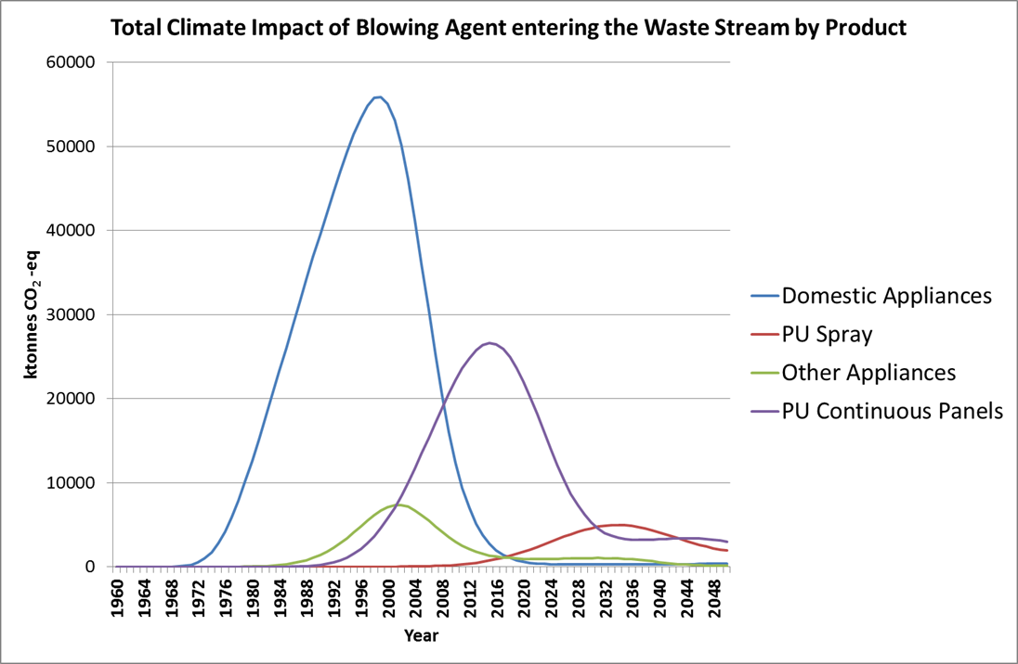

Figure 5: Variation in the size and timing of blowing agent waste flows

Identifying Blowing Agents in the Waste Stream and other Waste Management challenges

Once in the waste stream, such banks are broadly unreachable and the environment needs to rely on natural mechanisms such as anaerobic degradation to avoid the worst impacts of eventual blowing agent emission. Increasingly, ODS-containing foam is being treated as hazardous waste in a number of regions in an effort to avert uncontrolled landfilling, but the over-riding challenge is to be able to police shipments sufficiently well to avoid the practice when there is no simple way of determining the identity of the foam blowing agent routinely. The search for such detection equipment continues, since it would not only allow for the characterisation of waste, but would also assist customs officials on cross-border trade of foam products where blowing agent restrictions may already be in force.

Assigning value to Blowing Agent recovery and likely impact on trends going forward

A further option for limiting the quantity of ODS-containing and other high GWP blowing agent foams going to landfill is to encourage voluntary intervention at the point of decommissioning by assigning value to the recovery and destruction of the foam or its blowing agent. At present, this value is most likely to arise from the climate benefits associated with the activity. However, an additional point of concern is that the average global warming potential (GWP) of the waste stream will decrease with time as the very high GWP blowing agents (e.g. CFCs) become less prevalent. Figure 6 illustrates how this can happen:

Figure 6: Expected decline in average GWP of the waste streams for typical foam applications

These trends imply that it is preferable to introduce effective waste management practices in the period prior to 2030 for PU Spray Foam. However, more importantly, they indicate that much of the climate benefit arising from the management of appliances foams has already passed. This is being borne out in practice for many appliance recycling plants, where the associated climate benefit cannot now be relied upon as a justification for investment. The consequence is that waste handling companies are looking to minimise their upfront investment costs in equipment and manual dismantling practices are becoming increasingly common for foam separation, even though there are associated emissions. This is especially the case in areas of low population density, where the economies of scale are more limited.

Best Practice in the management of Insulation Foams and the importance of Segregation

Figure 7 provides a schematic diagram of the lifecycle of an insulation foam, illustrating the points at which blowing agent releases are likely. Since most new production and installation is now taking place with non-ODS blowing agents, the focus of ODS emission minimisation is at the point of decommissioning and thereafter. The effectiveness of this whole process is measured by the Recovery and Destruction Efficiency (RDE). The ability to maximise RDE lies in the degree to which insulation foams being decommissioned can be separated and segregated from other building demolition waste. The level of waste segregation varies substantially by jurisdiction and those with high levels of segregation achieve the best results in ODS recovery/destruction at lowest incremental cost.

The choice exists to either directly incinerate the insulating foam or to shred it and recover the blowing agent for subsequent destruction. The latter approach is only really cost-effective where there are economic benefits from other components of the building element (e.g. steel from metal-faced panels). In Europe and Japan, where efforts to recover blowing agents have been most extensive to date, there is an increasing tendency to move to direct incineration in order to minimise cost, although this depends largely on the availability and permissibility of use of Municipal Solid Waste Incinerators.

Figure 7: Schematic of Emission Sources and Blowing Agent Management Options for Insulating Foams (Source: SKM Enviros/Caleb)

Membership of the Foams Technical Options Committee

The following list represents the members of the Foams Technical Options Committee who have contributed to the content of this Report through the assessment period.

RAPRA Report ‘The Future of Polymer Foams: Market Forecasts to 2019’
Data adapted from Special Report on Ozone and Climate (2005) – values include hydrocarbons
Rescinded in December 2012
RAPRA Report ‘The Future of Polymer Foams: Market Forecasts to 2019’
Data adapted from Special Report on Ozone and Climate (2005)

